TOWN & POORS CHARITY FIELD AGENDA

Thursday 20th June 2019 (following the Parish Council meeting)

- Apologies for Absence

- To approve Minutes of the Charity Meeting on 16th May 2019

- Matters Arising

- Finance:
  - Charity accounts report
Balance at 11th June 2019: £4089.98

  - Expenditure for approval 20th June 2019:

- To further discuss the future use of the field, water supply, maintenance and security of the field
5.1- Allotments in Spaldwick- Bee-keeping request email- a/w permission to add to agenda response
5.2 Setting up an Allotment Association

- Correspondence

- Any other business

8. Date of the next Meeting– Thursday 18th July 2019

Yours sincerely

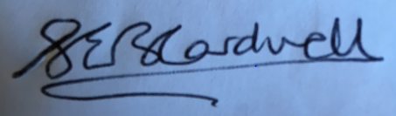

Signed (Clerk) Sarah Cardwell Date: 14th June 2019

