SPALDWICK PARISH COUNCIL
CHAIRMAN: Steve Fane de Salis
Clerk to the Council
Mrs Sarah Cardwell
63 Highfield Avenue
Alconbury Weston
Huntingdon
Cambs
PE28 4JS
clerkspaldwick.pc@gmail.com
www.spaldwickparishcouncil.org.uk/

5th May 2020

Dear Member
You are hereby summoned to attend the Parish Council Meeting which will be held on Monday 11th May 2020 at 8pm. In accordance with The Local Authorities and Police and Crime Panels (Coronavirus) (Flexibility of Local Authority and Police and Crime Panel Meetings) (England and Wales) Regulations 2020 (“the 2020 Regulations”) this meeting will be held remotely by Zoom videocall. The meeting will deal with the following business: Public and Press are invited to attend

NOTICE and AGENDA

20/05/1 To Receive Apologies and Reasons for Non-Attendance

20/05/2 Declarations of Interests for Members (Disclosable Pecuniary Interests)

20/05/3 Public Open Forum
Each person wishing to address the council will be allowed to speak for a maximum of 5 minutes subject to the Chairman’s discretion. This part cannot be longer than 10 minutes per item.

20/05/4 Finance: To discuss 3 urgent quotes for fencing and installing water pipes and troughs to the
Allotment Plots
20/05/5 Councillors’ questions
Please, note that no decisions can lawfully be made under this item. Business must be specified
therefore the Council cannot lawfully raise matters for decision.

20/05/6 Date of the next meeting: Thursday 21st May 2020 at 8pm (web meetings to continue as long as required).

Signed (Clerk) Sarah Cardwell 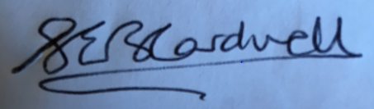
Date: 5th May 2020

